The Colorful World of Leonor Fini: Surrealism’s Pioneering Non-Conformist

By Emily Burkhart | March 18, 2022

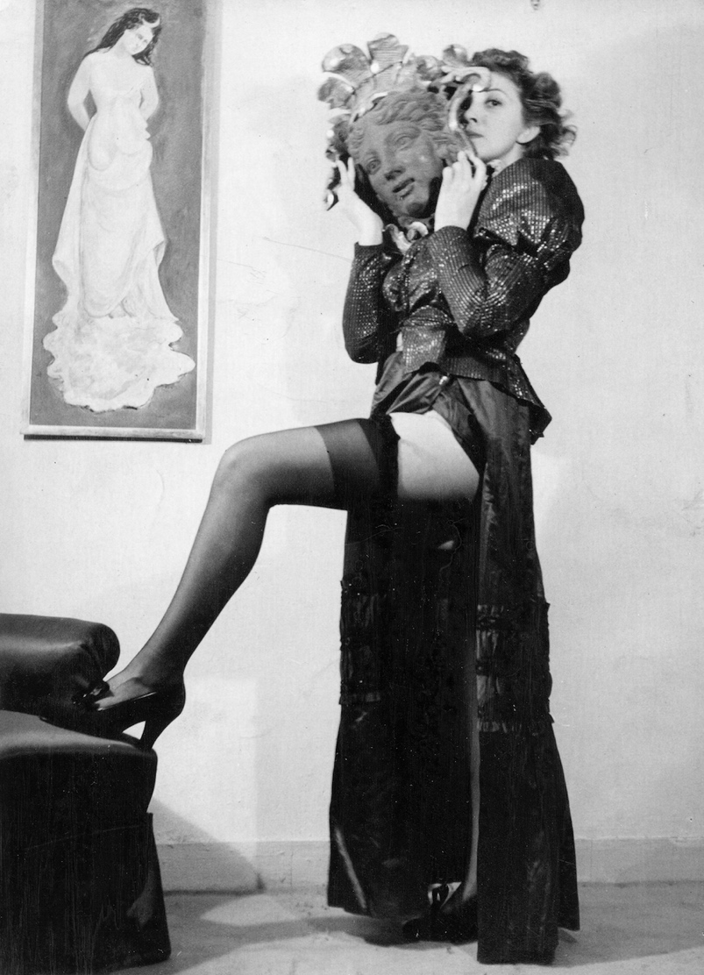
Leonor Fini in Paris, ca. 1938. Unknown photographer, The Estate of Leonor Fini. Image courtesy of The Paris Review.

Rebel, goddess, siren, provocateur, iconoclast–the Argentinian-Italian Surrealist Leonor Fini (1907-1996) defies categorization. She is considered one of the most important women artists of the mid-twentieth century (although she would hate to be classified as such) along with Leonora Carrington, Frida Kahlo, Meret Oppenheim, Remedios Varo, and Dorothea Tanning. Known equally in her time for her larger-than-life personality as well as her art, Fini employed what curator Alyce McMayon has called “self-fashioning “ to shape public perception of herself and cultivate the image of a confident, sexually liberated femme fatale. She also rather eccentrically kept a large number of Persian cats, many of which feature in her paintings.

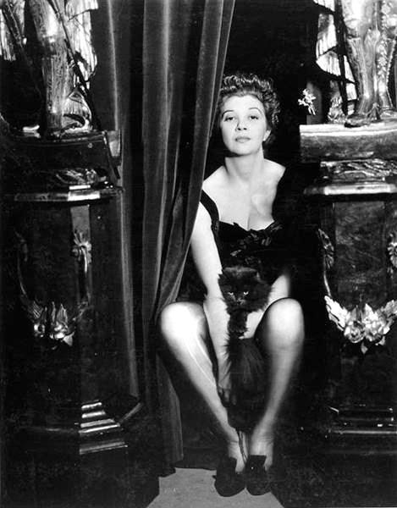
Leonor Fini with one of her cats in an undated photograph by Surrealist Dora Maar. Image courtesy of WikiArt.

Childhood
She was born Eleonora Fini on August 30, 1907, in Buenos Aires, Argentina, to Malvina Braun Dubich, a woman of German, Slavic, and Venetian ancestry, and Herminio Fini, a wealthy Argentinian with family roots in Benevento, Italy. Her mother left Herminio, a tyrannical, violent man, and fled with eighteen-month-old Leonor to her native Trieste, an Italian city in the Austro-Hungarian Empire at the beginning of the twentieth century. An independent, strong-willed woman, Malvina disguised Leonor as a boy until she was seven so Herminio’s spies could not find them and return Leonor to her father. A devout Catholic, Herminio refused to grant Malvina a divorce until 1919. Leonor’s childhood experiences in disguise influenced her use of costume as a means of self-expression throughout her life.

Childhood and Education
As a child, Fini was fascinated by death and decay, which would later become a theme in her art. She was expelled from a series of schools throughout her youth and had little formal artistic training. Instead, she read about art in books from her uncle’s library, traveled widely, and visited art museums throughout Europe, absorbing composition and technique from the Old Masters whose works she copied on her travels. Fini learned anatomy directly from studying cadavers in the local morgue, the influence of which can be seen in many paintings including Angel of Anatomy (1949), which features her own face.
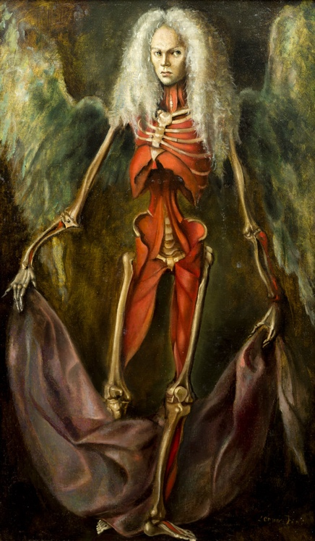
Angel of Anatomy, 1949, Leonor Fini. Oil on canvas, private collection. Image courtesy of All Art .

Early Paintings and First Exhibitions
In her teens, Fini suffered from rheumatic conjunctivitis and was required to wear bandages on both eyes for two months. She later recalled that living in the dark had given her the opportunity to form and visualize elaborate images from her imagination. Her earliest paintings were portraits, a genre she would return to throughout her life, such as the astonishing Portrait of Mrs. Hasellter from 1942. Fini exhibited her first work publicly in Trieste in 1927 in a group exhibition at the age of seventeen.
Subsequently, she received a commission to paint portraits of dignitaries from Milan and had her first one-person show there at the Galerie Barbaroux in 1929.

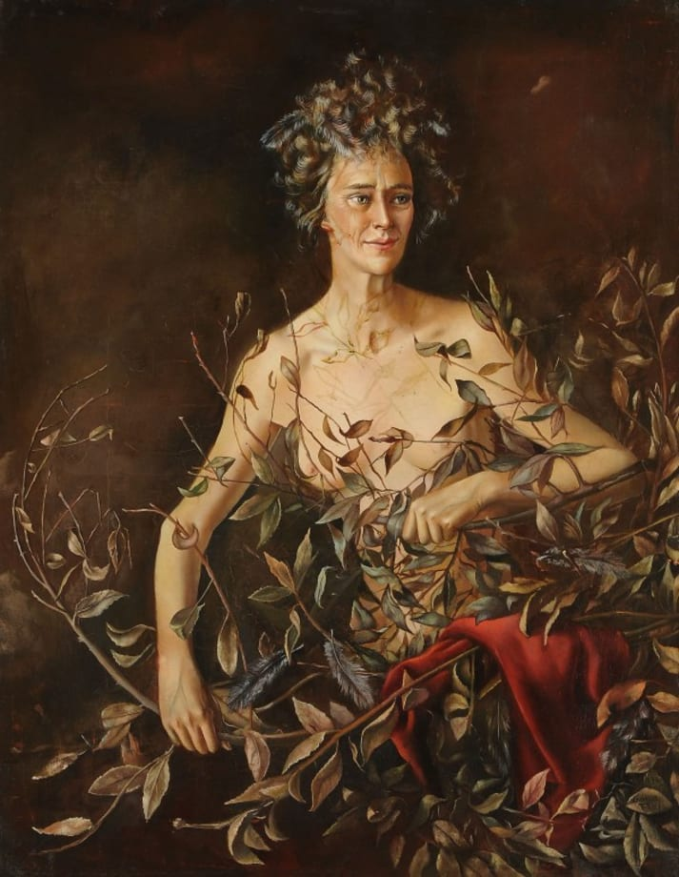
Portrait of Mrs. Hasellter, 1942, Leonor Fini. Oil on canvas, Francis M. Naumann Fine Art. Image courtesy of Art Basel.

Move to Paris and Introduction to Surrealism

A move to Paris in 1933 connected her with the Surrealists, including Paul Éluard, Man Ray, Max Ernst, and Salvador Dalí. She quickly became known for her eccentricity, not only in her art but through her costume-like clothing and theatrical behavior. Though she never became an official member of their group, Fini exhibited with them in London in 1936. Her work began to explore Surrealist themes–dreams and the unconscious, mythological and fantasy motifs, and metamorphoses of the mind and body, such as The Curious (1936) and Two Women (1939), where doors in both seem to be passages to other worlds of physical and spiritual transformation. Fini’s work was also introduced in the United States at this time. In 1936, Julien Levy presented her at his New York gallery in a joint exhibition with Ernst. Curator Alfred Barr also included Fini in his landmark exhibition “Fantastic Art, Dada, Surrealism” at the Museum of Modern Art the same year.

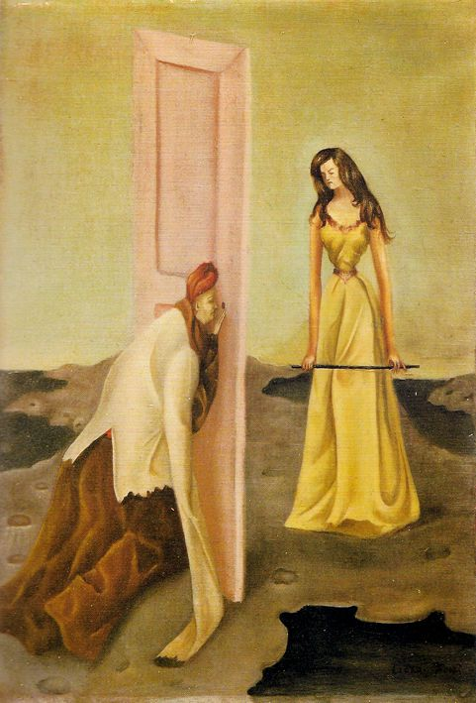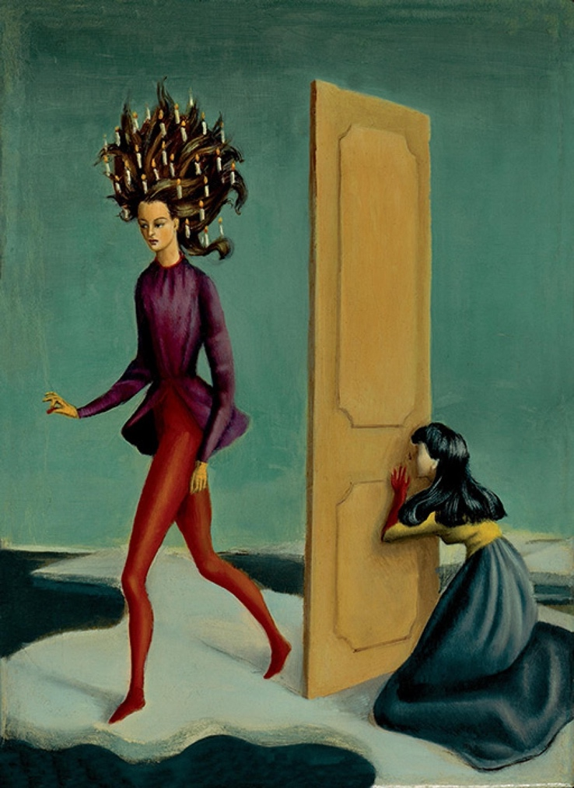
Left to Right: The Curious, 1936, Leonor Fini. Oil on canvas, private collection. Image courtesy of Biblioklept. Two Women, 1939, Leonor Fini. Oil on canvas, Artists Rights Society, New York/ADAGP, Paris. Image courtesy of Obelisk Art History.
Sexuality and Gender Roles

Before her arrival in Paris, Fini was engaged to a minor Milanese nobleman in 1932 and later was briefly married to Federico Veneziani in 1941. She never married again nor had children. Fini had numerous affairs with women and described herself as bisexual. She was also openly polyamorous and lived for many years with two male lovers. Among her wide circle of artist friends, many were former flames. Her refusal to be categorized in any way, especially through gender norms, put Fini ahead of her time in believing that identity, like artistic expression is never fixed–it must constantly be open to inspiration and imagination.
Her paintings often presented women in positions of power where they control the narrative and are not beholden to men, articulating a clear female gaze. The Shepherdess of the Sphinxes (1941), wherein Leonor portrays herself as a guardian watching over her “flock,” exemplifies this. Art collector Peggy Guggenheim acquired the work in 1942 and included it alongside one of Fini’s self-portraits in Exhibition by 31 Women in Venice in 1943.

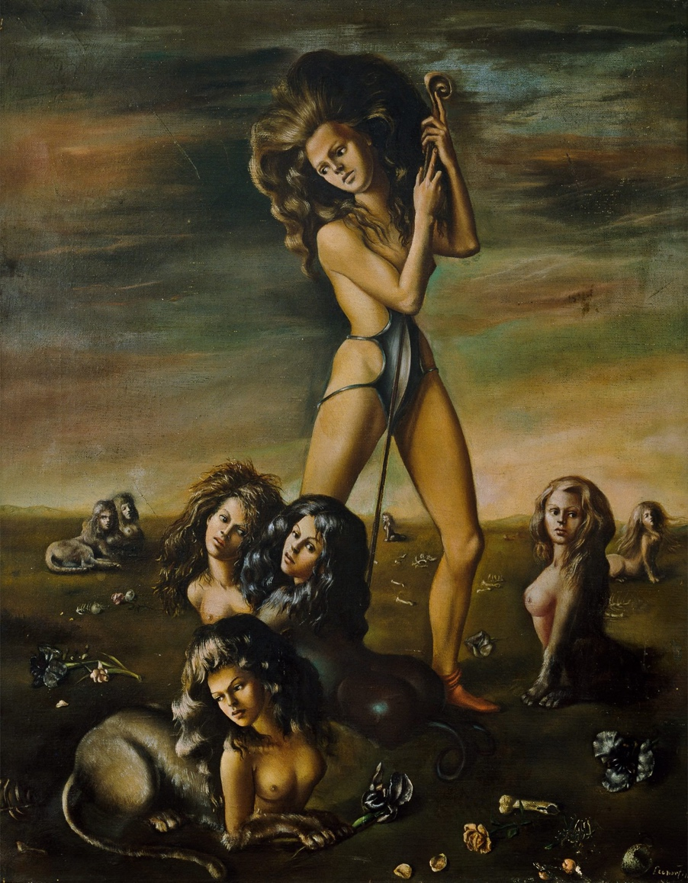
The Shepherdess of the Sphinxes, 1941, Leonor Fini. Oil on canvas. Peggy Guggenheim Collection, Venice. Image courtesy of the Peggy Guggenheim Collection.

Themes

Fini’s art explored female identity and sexuality. She preferred androgynous men in touch with their feminine side, not macho or hypermasculine types. Her images are permeated with longing, desire, eroticism, death, and rebirth. In The Ends of the World (1948), Fini again used herself as model, a half-submerged figure in a black pool of water, her reflection feline, set in an apocalyptic scene of wilted leaves, plants, and ghostly skull-like creatures with sunken eyes.
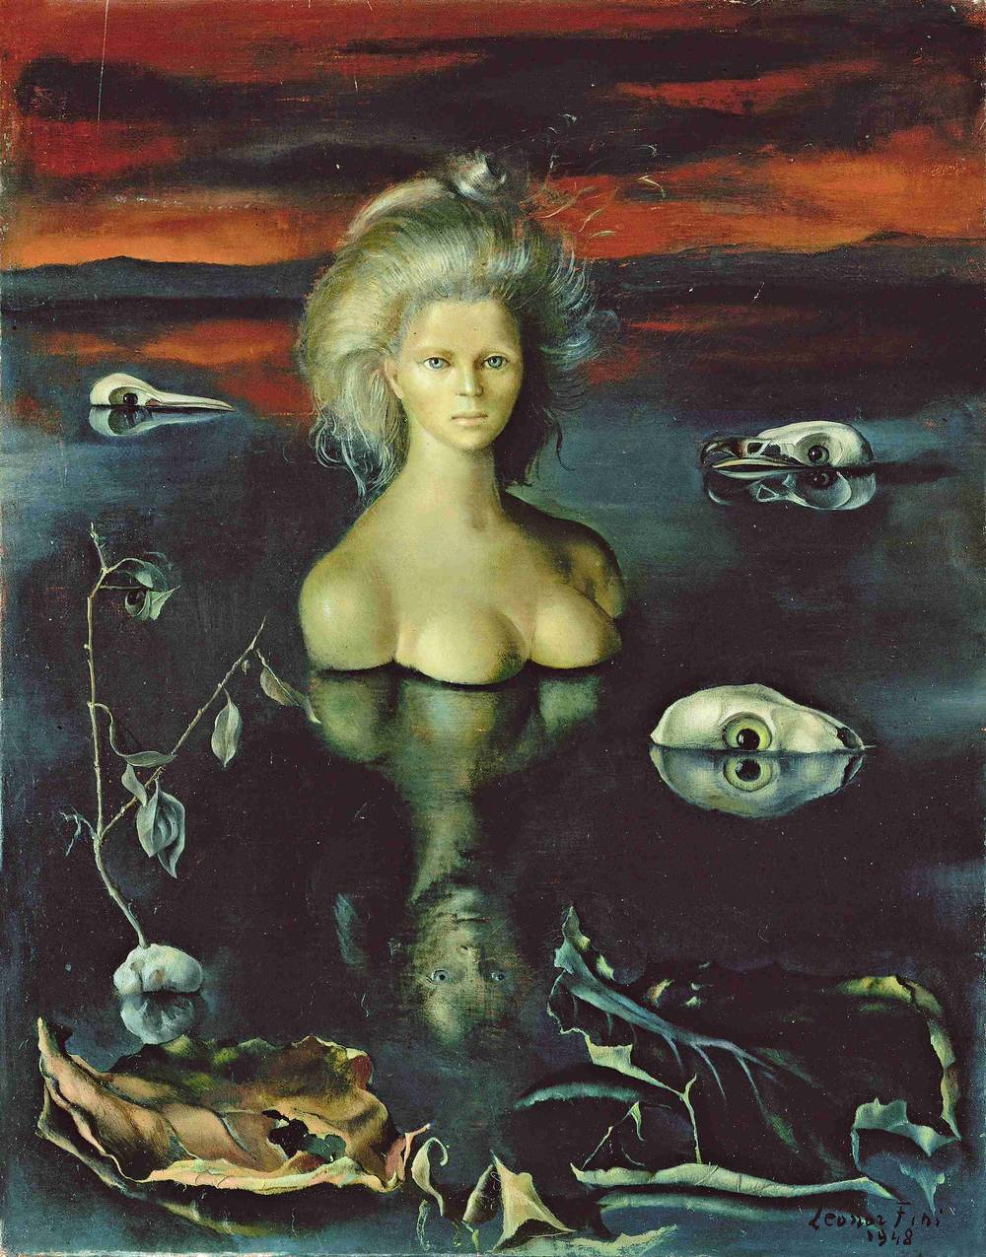
The Ends of the World, 1948. Leonor Fini. Oil on canvas. Galerie Minsky, Paris. Image courtesy of Schirn magazine.

The use of symbolic, mythological imagery, particularly that of the sphinx, a supernatural creature and symbol of treachery with a lion’s body and a human head, became Fini’s alter ego and a recurring motif in her work. For example, the sphinx in the Little Guardian Sphinx (1943-1944) bears Fini’s face. The parchment at its feet evokes the riddle of the sphinx from the Greek tragedy of Oedipus. Iconography of woman as warrior, guardian, witch, and goddess also recurs in Fini’s paintings. Notably the erotically charged Chthonian Deity Watching Over the Sleep of a Young Man from 1946 depicts the female face of a sphinx as one of the deities inhabiting the underworld, presiding over the slender nude form of a young man in repose.

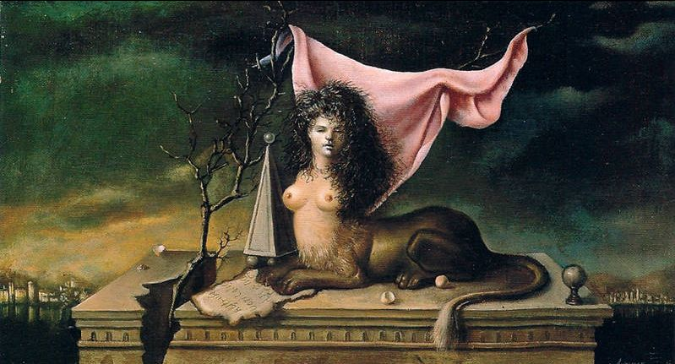
Little Guardian Sphinx, 1943-1944, Leonor Fini. Oil on canvas, Galerie Minsky, Paris. Image courtesy of The Poet’s Glass.

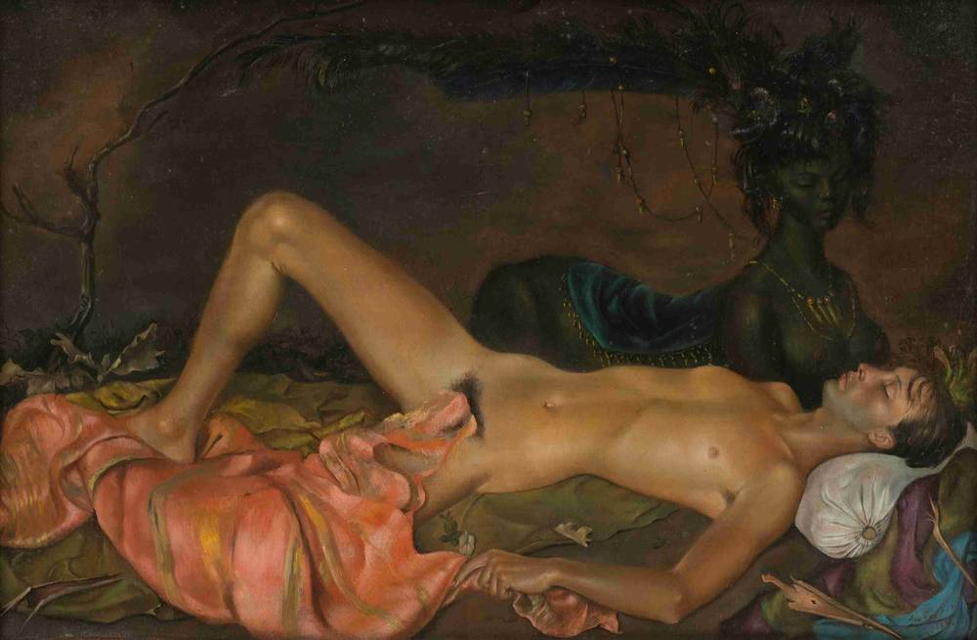
Chthonian Deity Watching Over the Sleep of a Young Man, 1946, Leonor Fini. Oil on canvas, Francis M. Naumann Fine Art. Image courtesy of Art Basel.

Opposition to Surrealist Thought

Although she exhibited in major Surrealist surveys throughout the 1930s and 1940s, Fini rejected the movement’s traditional view of woman as muse. She disagreed with prevailing attitudes about the role of women in art. She despised Surrealism’s theorist André Breton’s misogynistic ideas about women as sex objects inspiring male genius but incapable of artistic greatness equal to men. Nevertheless, despite this disdain, Fini’s work has been included in nearly every Surrealist exhibition since 1936.

Conclusion
Over the course of six decades, Fini’s oeuvre expanded from painting to include graphic design, book illustration, product design, and set and costume design for theatre, ballet, opera, and film. Forward-thinking, the dreamlike scenes of dominant women and passive men that undercut conventional notions of sex and gender in her painting paved the way for women and LGBTQIA rights. She rejected the label of woman artist by the feminist art historians of the 1970s preferring to be known for her art rather than her gender. Fini lived life on her own terms and was a sexually liberated woman, her extravagant lifestyle, theatricality, and love of spectacle influenced diverse artists from Andy Warhol to Madonna in the 1980s. She died of pneumonia at the age of eighty-eight in 1996. In honor of Women’s History Month, make checking out the work of this often overlooked Surrealist a priority.

